RESOLUTION NO.__________

RE: CERTIFICATE OF APPROPRIATENESS UNDER THE
PROVISIONS OF THE ACT OF THE PENNSYLVANIA
LEGISLATURE 1961, JUNE 13, P.L. 282 (53
SECTION 8004) AND BETHLEHEM ORDINANCE NO.
3952 AS AMENDED.

WHEREAS, it is proposed to install signage and fencing at the new school building at 321 E. Third Street.

NOW, THEREFORE, BE IT RESOLVED by the Council of the City of Bethlehem that a Certificate of Appropriateness is hereby granted for the work.

Sponsored by: (s)

(s)

ADOPTED BY COUNCIL THIS DAY OF

(s)
President of Council

ATTEST:

(s)
City Clerk

HISTORIC CONSERVATION COMMISSION

CASE # 556 – It is proposed to install signage and fencing at the new school building at 321 E. Third Street
OWNER/APPLICANT: Charter Arts Foundation / Christine Ussler, Artefact Inc.

The Commission upon motion by Mr. Evans seconded by Mr. Silvoy adopted the proposal that City Council issue a Certificate of Appropriateness for the proposed work described herein:
- The proposal to install signage and fencing at the new school building at 321 E. Third Street was presented by Diane LaBelle and Christine Ussler.
- Three signs will be pin mounted to the façades and located on the east, south and north sides as shown in the drawings submitted. “CHARTER” and “ARTS” will be halo lit from behind. “CHARTER” will have white light and “ARTS” will be lit with light in matching colors to the letters – red, green, blue, and purple. A vertically oriented sign reading The Lehigh Valley CHARTER High School for the ARTS will be located on the east stair tower wall between its windows. It will be 33’ tall and 27” wide except at two locations where it will be 8’5” wide. On the front façade the sign will be located above the entrance and read only CHARTER ARTS. This sign will be 14’11” wide and 25 ½” high. On the rear façade the sign will be located at the top of the façade just below the roofline and will also read only CHARTER ARTS. It will be approximately 47’ wide and 47 ½ ” high.
- Black wrought iron fencing will be installed on 3rd and Polk Streets. The wrought iron fencing will be 3’ high on the east side and located on the two low curbs and 6’ high along Third St. at the park.
- Black chain link fencing will be installed on Columbia St. at the service area. The black chain link fence will be 6’ high along Columbia St. and include (3) 12’ wide gates.
- The proposed motion was unanimously approved.

CU: cu
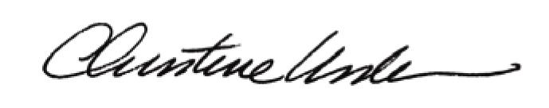

By:

Date of Meeting: June 15, 2015 Title: Historic Officer

